Visual Basic 7070 Project
Tiger Athletic Foundation Seat Management System

By Team: Gourds

Yifeng Zhang
Huidong Ma

(Latest Revised Version on Oct 23, 1998)

TABLE OF CONTENTS:

- Background
- Design and Function
- Database Design
- Splash Screen
- Main Form
- Crystal Report
- Display Utilities
- Query and Search
- Database Operation
- User manual
- Considerations
- Distinguishing between Chairs and Benches for TAF seats
- Tradeoff between speed and size
- Year-end
- Parking
- Suggestion for future development
- Developer's Information

Visual Basic 7070 Project Report

- Background:

The TAF (Tiger Athletics Foundation) provides LSU football season tickets for its members. Presently, their method of keeping track of and recording all of their ticket assignments is done by manually writing the tickets on a series of poster boards. Due to this unreliable and inefficient method, TAF is in dire need of front-end ticket-management application for assigning and managing their season football tickets. This system should also assist them in maintaining TAF member information. This challenging project has been assigned for the summer 1998 Visual Basic 7070 Project. We have developed such an application for TAF using Microsoft Visual Basic 5.0 and Microsoft Access for the front-end application and database management respectively. It dramatically increases the efficiency and is designed to be very easy to operate and manage.

Our team is comprised of four members: Xiaojun Ding, Michael Loft, Huidong Ma, and Yifeng Zhang. Although the initial level of Visual Basic knowledge spanned a wide range among the individual members, we each learned from each other's specific expertise and came away from the project with a greater amount of VB, database, and team working skills. During the initial project development and planning, Huidong Ma, Yifeng Zhang and Michael Loft worked together to carefully plan out the application. This included creating TOE charts and designing the database from the existing Access file provided by the TAF. Xiaojun Ding later joined the team and created the majority of the graphics for our application. This included our splash window and LSU tiger stadium graph. The coding of the project was a collaborative effort by the entire group with Huidong Ma andYifeng Zhang utilizing their advanced visual basic skills to lead the team.

- Design and function:

1. Database design:
Our database (TAF.mdb) contains 4 tables, which are: "section", "customer", "club", and "logon".

- "section" table:
Contains information about the stadium section. The fields contained in the table are:
- MemberID: Member ID of TAF customer assigned to the specified seat (Foreign Key of customer Table).
- Year: The year of the ticket assignment
- Section: stadium section code (e.g. W1 means section number one on the west side of the stadium)
- Seat ID: seat ID for query
(Year, Section and SeatID combined as the primary key of "section" table).
- Row: Row position of seat in the section
- Column: Column position of seat in the section.
- Category:
- Stadium: General Stadium Seat that has not been assigned to TAF.
- TAF: (TAF Seat) Stadium seat that has been assigned to TAF.
- Customer: Seat assigned to TAF member and has not confirmed.
- Cfirmed Cus: Seated assigned to customer and has been confirmed.
- Lastname: Last name of TAF customer assigned to the specified seat.
- Firstname: First name of TAF customer assigned to the specified seat.
- Surcharge: Surcharge of the section. (West and East side is $50.00 and South and North Side is $25.00).
- Donation: Donation provided by TAF customer.
- Club Level: Club level of TAF customer.(Foreign Key of club Table).
- Priority: Priority of TAF customer.

- "customer" table:
Contains customer information of TAF.
- MemberID: Member ID of TAF customer of the specified seat.(Primary Key)
- Lastname: Last name of TAF customer of the specified seat.
- M/Initial: Middle/Initial name of TAF customer of the specified seat.
- Firstname: First name of TAF customer of the specified seat.
- Suffix: Mr./Mrs.
- Title: Title of TAF customer.
- SSN: Social Security Number of TAF Customer.
- Gender: Gender of TAF customer.
- Birthday: Birthday of TAF customer.
- Company: Company in which TAF customer works
- Address: Address of TAF customer.
- City: City in which TAF customer lives.
- State: State in which TAF customer lives.
- Zip: Zip of TAF customer address.
- Telephone: Telephone number of TAF customer.
- Email: Email of TAF customer.
- Donation: Donation provided by TAF customer.
- Club Level: Club level of TAF customer.(Foreign Key of club Table)
- Check #: Check #/ Credit Card of payment by TAF customer.
- Date Rcd: Date Check/Credit Card payment received.
- Amt Rec'd: Amount of payment received.
- Priority: Priority of TAF customer.
- Parking lot: Parking lot assigned to TAF customer.
- Comment₁: comments for TAF customer.

- "club" table:
Contains TAF club level information:
- Club Level: Club Level code. (Primary Key)
- Donation Range: Donation range of specified Club Level.
- Description: Description of specified Club Level.

- "logon" table:
Contains authorized Usernames and associated Passwords.
Username: Authorized User name.
Password: Password associated with the Username.

Relationship:

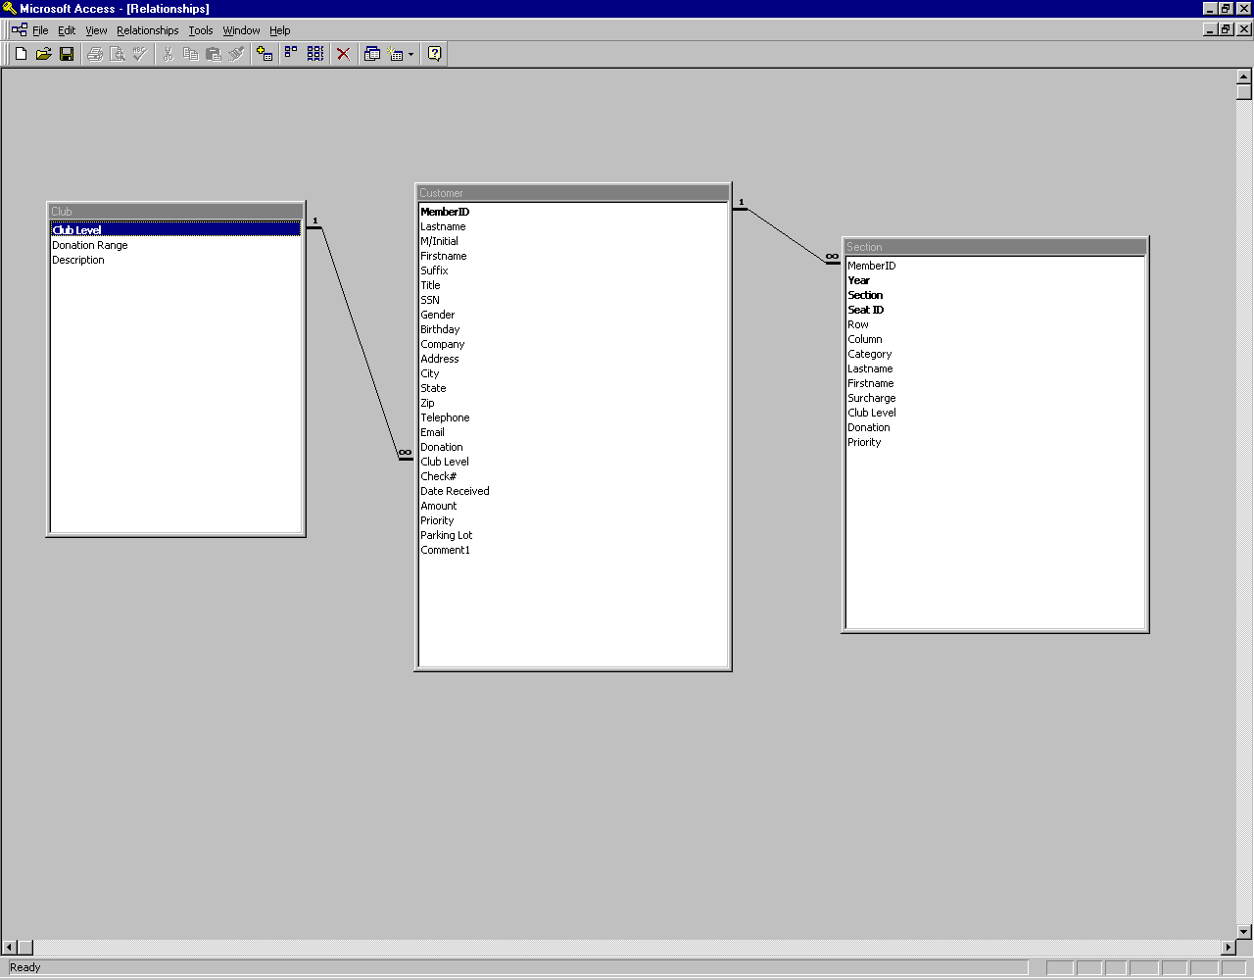
Fig 0

2. Splash Screen

- The splash screen can give a user an introduction to the program. It acts as a prelude to the application and supplies the user with information about the program.
- The splash screen also aids the program when loading to make it seem that it is loading faster.
- We have used a photo of LSU's Tiger stadium as the background image of the splash screen. We edited the photo to be more transparent in Adobe PhotoShop, and put an additional photo of a tiger player on top of the background image. Placing a "Tiger Athletic Foundation" label and displaying the programmer information completes the splash screen.
- Ideally, we intended to load the splash screen modelessly—displaying the splash screen while the main form is loading, but this did not succeed. Visual Basic had a problem reading our background image so we have modified the splash screen by adding a "Continue" command button.

3. Main Form

- Once the user has logged in the initial screen is our main form, which is viewed as a map of the Tiger Stadium. It provides the user with a convenient way to access a desired section and operate the seat-assignment functions.
- We have made the map more appealing by editing it in PhotoShop and then placing the image on the form. In order to access the individual sections on the map, we created an array of labels for each section. The advantage of using an array is that it is easier to code and is more efficient—with each different index, we can access the specific section.
- A small problem with our main form is that Visual Basic does not have very strong drawing and graphical capabilities. Although we tried several different methods, some irregular shaped sections cannot be filled perfectly with a label. So in some special cases, it is required that user click directly in the middle of the section to access that section's information.

4. Crystal reports

For the convenience of the user, we have coded and used the Crystal Reports Tool to create several Report Functions for the user. The user can easily create a report about TAF customers, stadium sections or TAF club level information. They can view and print the reports.

- Display Utilities

We also provide display utilities for the user to view the information about the customer, section and club level. This display utility provides instant access to desired reference information. Please refer to User Manual for more detailed information regarding this function.

- Query and Search

We have also provided very functional query utilities for the user allowing them to access information they want according to specific criteria. The user can specify the query criteria from the query form or create their own SQL statements. Our query functions allow the user to run the multiple condition queries. Please refer the user manual for more detailed information.

7. Database Operation

The user is also given direct access to the data in the database from our VB application. The user can add, edit, or delete a customer and their information from the database through the database interface. This allows the user to view the detailed information of each customer. For the convenience of the user, we have also provided a similar interface in Microsoft Access for the user to maintain the customer information. Please refer to User manual for more detailed information.

- User Manual:

When the application is first run, the following splash screen appears. It informs you that the TAF ticket management system is running. (Fig 1)

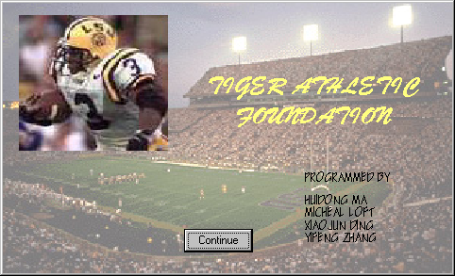
Fig 1

To continue into the program, you need to click the [Continue] button on the splash screen. After you have clicked the [Continue] button, the logon form will pop up and you will be prompted to enter your valid username and password to enter the system.(Fig 2)

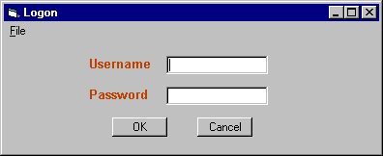
Fig 2

Once you have entered your username and password, click the [OK] button to continue. You will see the stadium map as the following. (Fig 3)

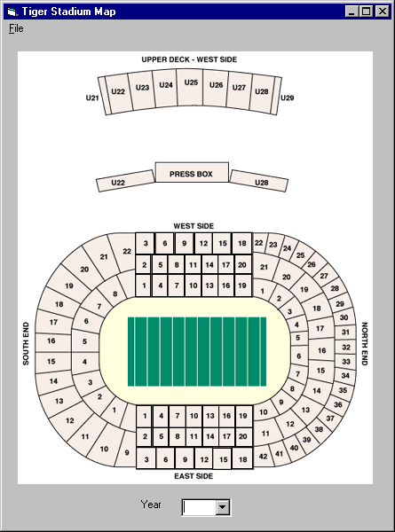 Fig 3

In this stadium map, you will see the position of each section and the structure of the stadium. You can also see the year selection on the bottom of the stadium map. To see the detailed information for the seats in each section for a specified year, simply choose the year first and then click on one of the section numbers (Presently the following sections are available: E5, N39, U24, U25, W7). For example, if you want to view the section assignments of the fifth section on the East side of the stadium in 1996, simply choose the 96 in year selection and then click on the section labeled "5" on the side of the stadium labeled "East Side". Once you have clicked on a desired section the sections form will appear.(Fig 4)

The individual section forms use the following color scheme to provide you with specific information about each individual seat:
- Green: Represents a stadium Seat that is not assigned to TAF.
- Yellow: Represents a stadium seat that has been assigned to TAF.
- Blue: Represents a customer seat (TAF Seat that has been assigned to a TAF customer but not confirmed by the customer).
- Cyan: Represents a confirmed customer seat (TAF Seat that has been assigned to customer and has been confirmed by the customer).

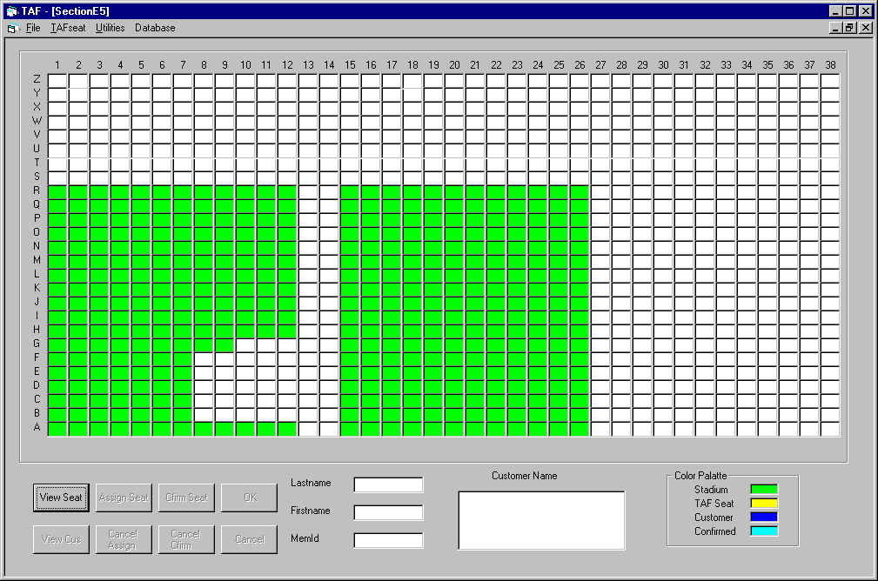
Fig 4

The title of the window above is labeled "SectionE5" which tells you the current section you are viewing. The following sections will walk a user through the different functions and features of the application.

- change to another Section
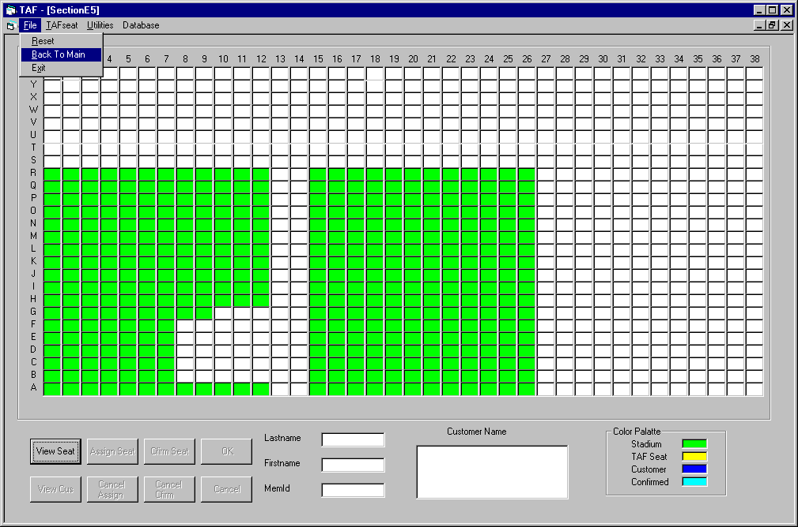
When you have finished viewing the chosen section you switch to another section by following the path [File]->[Back to Main] (as shown below) and the Stadium map interface will reappear. You can now follow the same instructions as above to select another section to view. (Fig 5)

Fig 5

- Resetting the database
When entering a new calendar year, the user can save the data to another data file and then use the existing data for operation of the New Year. To do this, you must follow the following menu path: [File]->[Reset], a warning dialogue box will remind you to save the data to another data file. If you click [continue], in the data record the "year" for all seats will be changed to the current year. The "Category" for the seats 'confirmed' will be changed to 'customer', ready for the confirmation in the new year.

- View TAF seat:
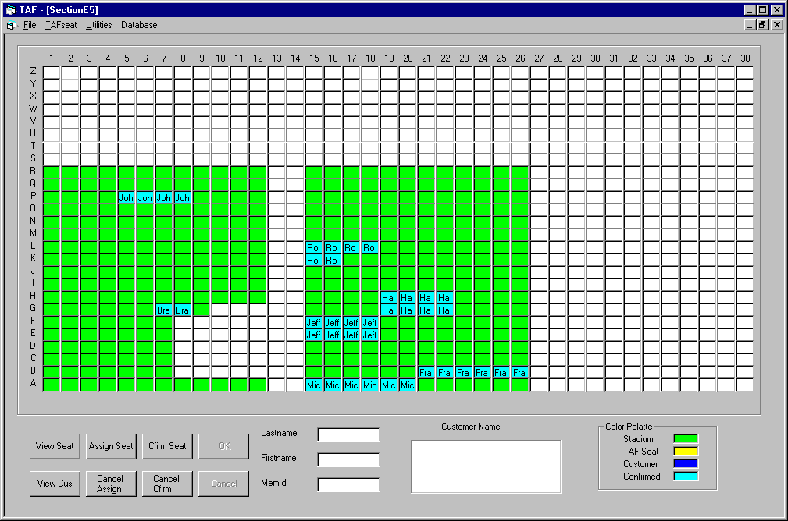
Once you have entered a section in order to view the seat information you must click the [View Seat] Button. Once this is done, the TAF seats that have been added in this section will show up corresponding to the color scheme documented above. (Fig 6) (Note: TAF seats will be the Yellow, Customer seats not yet confirmed will be blue and Customer seats confirmed will be cyan). By default, for a specified year in the past, the customer seat’s status is confirmed. (Fig 6)

Fig 6

- Add TAF Seat:
If the TAF receives new seat assignments and you want to add the seats to TAF you must follow the menu path: [TAFSeat] --> [Add TAF Seat]. Then click the stadium seat you want to add as a TAF Seat, as the seats are selected they will be red, it will look like the following.(Fig 7)

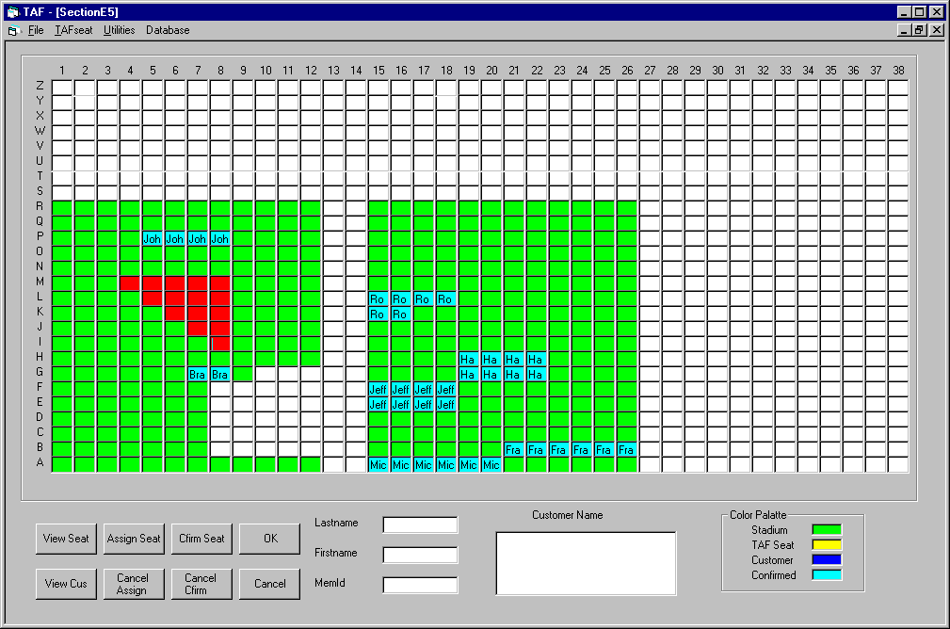
Fig 7

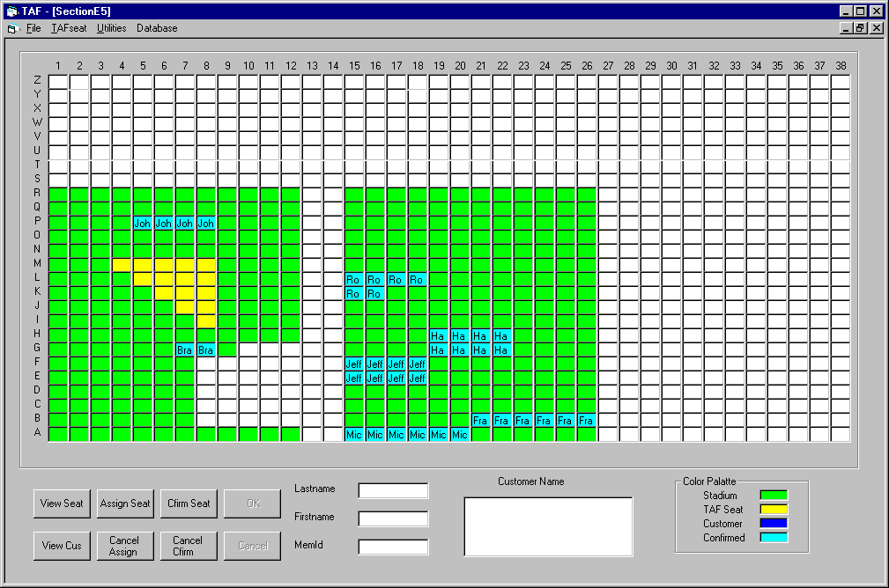
Once you have selected the seats that you wish to add to TAF you must then click [OK] and the seat will turn yellow. This means that it has been added to the database and is now assigned to TAF. . The Database will keep record of the change. The “Category” for the newly assigned seats will be “TAF”. The map will look like the following: (Fig 8)

Fig 8

- Delete TAF Seat:
If you learn that a seat that was assigned to TAF has been taken away you can delete the TAF assignment by following the menu path: [TAFSeat] --> [Del TAF Seat]. Then select the seats you wish to delete by clicking on them (they will turn red and the form will look like the following).(Fig 9)

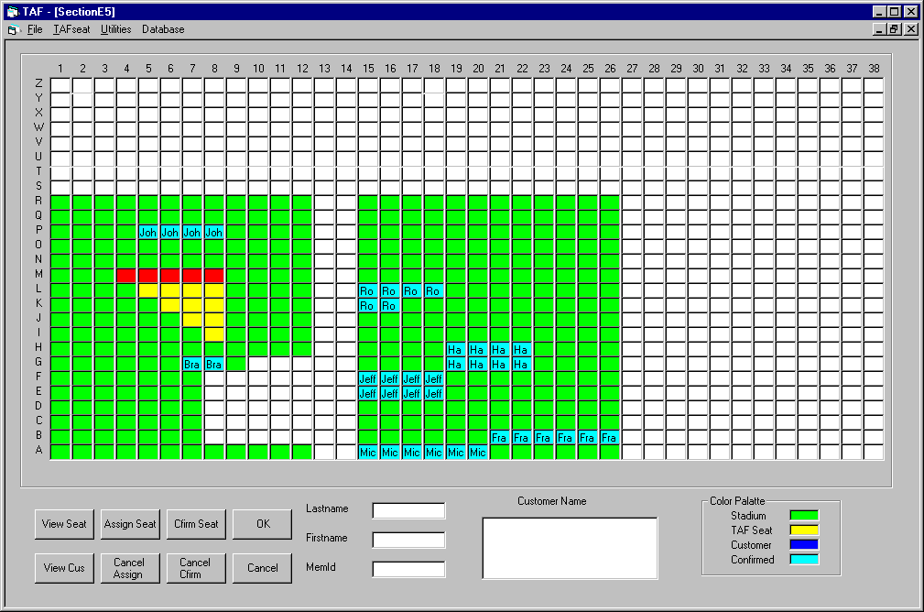
Fig 9

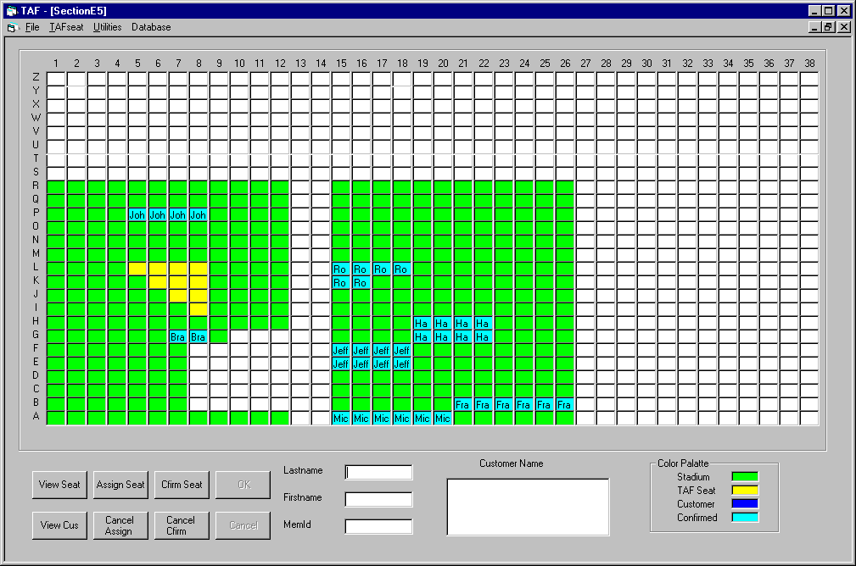
After they are selected (red) you should click [OK] and the seat will been deleted from the database as a category "TAF" seat. The Database will keep record of the change and the category will be changed to "Stadium". The seats will now return to their original color (Fig 10).

Fig 10

- View Customer Information:
If you would like to view customer information according to a seat assignment click on the [View Cus] button, then choose the customer by clicking on the seat you want to view (You can only view one customer every time). For example, the seat ‘P5’ has been assigned to a customer, if you would like to view the information of this customer follow the menu path above. It will look like Fig 11.

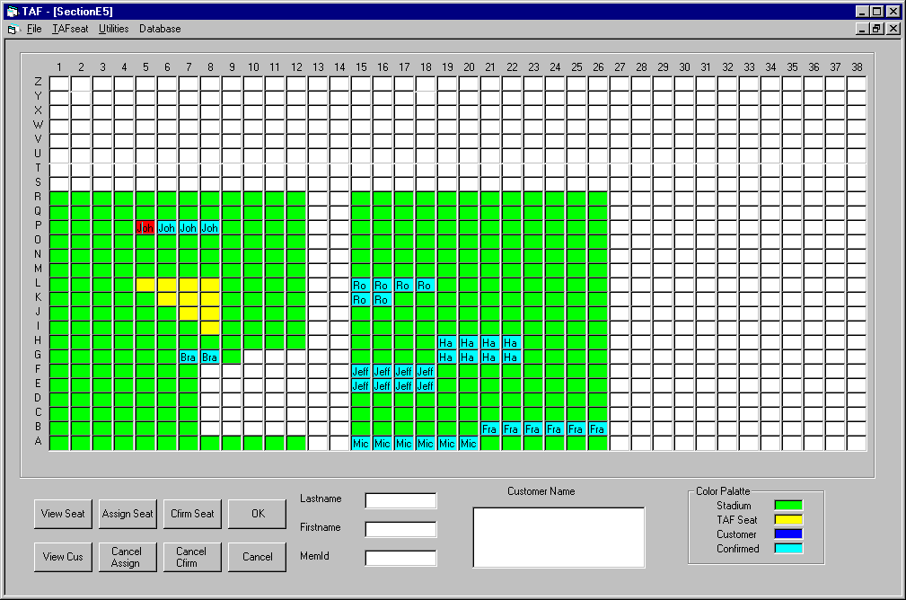
Fig 11

You then click on the [OK] command button and the information of this customer will appear in the text boxes at the bottom center of the page as follows: (Fig 12)

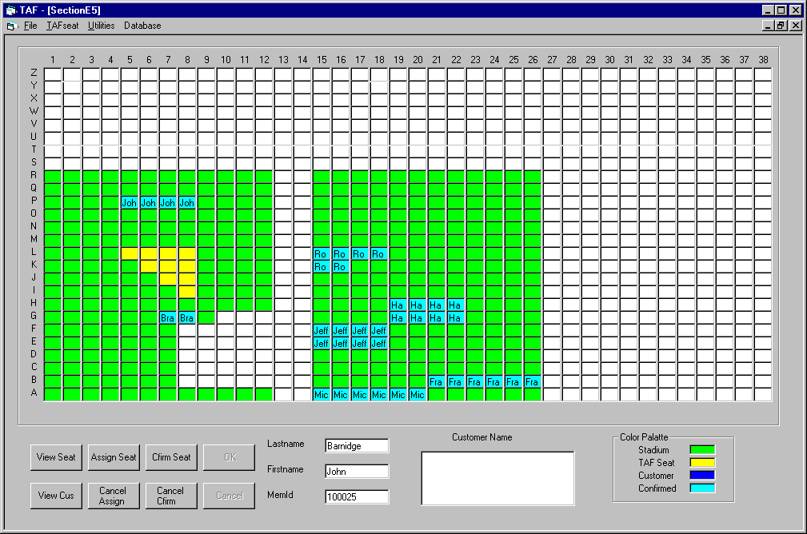
Fig 12

- Assign Seat to Customer:
To assign a TAF seat to a customer click on the [Assign Seat] button and the customer names will appear on the list box on the bottom right of the screen as follows: (Fig 13)

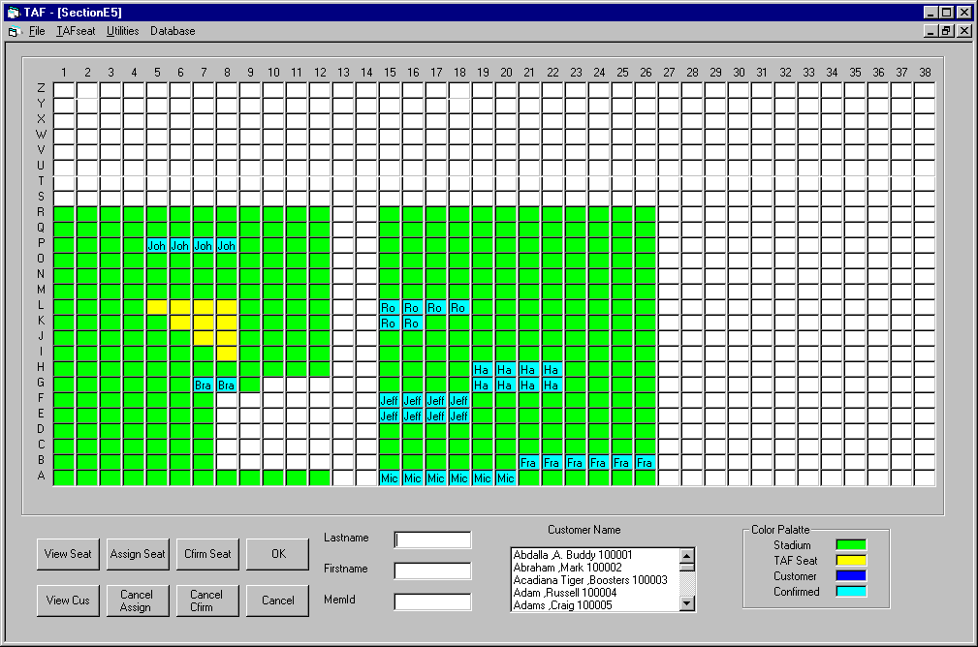
Fig 13

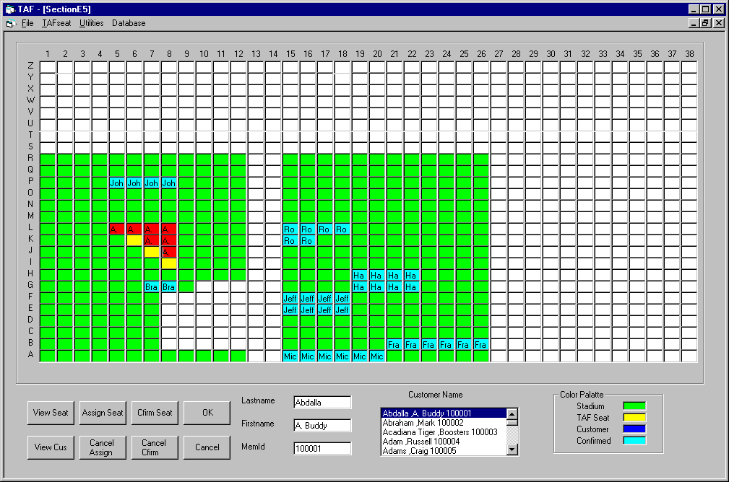
Choose the customer name that you wish to assign a seat to and click the seat you want to assign to him/her on the map. For example, if you want to assign seats to the first person in list: Abdalla A. Buddy, it will look as the follows (the seats that are red are going to be assigned to Abdalla A. Buddy).(Fig 14)

Fig 14

Then Click [OK] and the seats are assigned to him; the Database will keep record of the change. The “Category” of the seat will now be “Customer”. It will look as the following: (Fig 15)

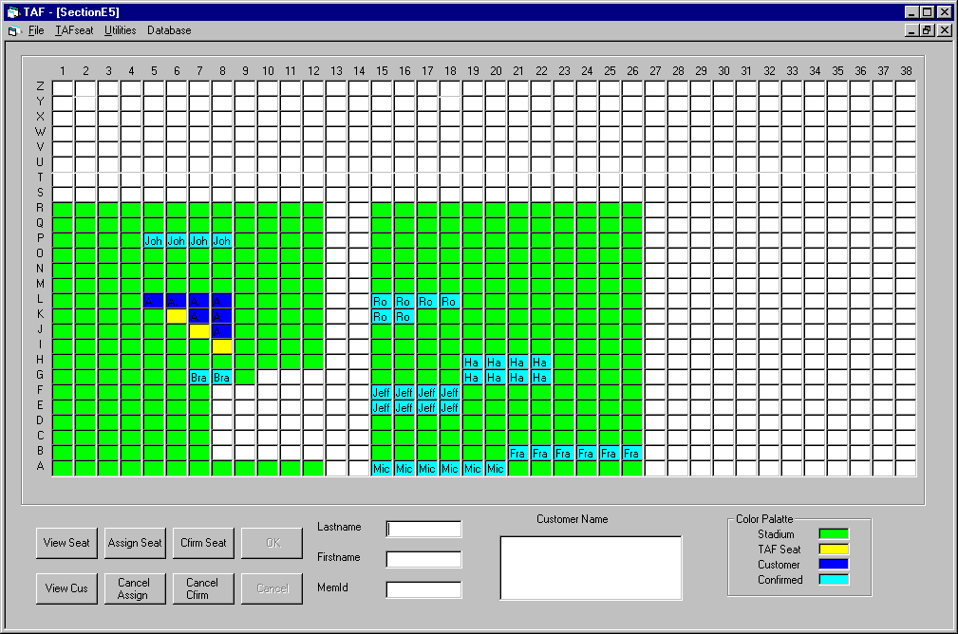 Fig 15

Remark: In the second phase of implementation, in order to show the different club levels of the customers, when assign a seat to a customer, the club level of that customer should be entered.
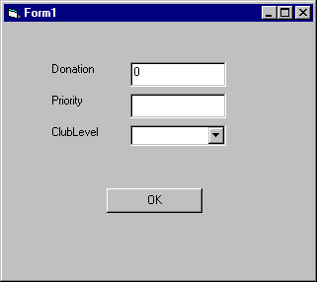

- Cancel the seat assigned to customer:
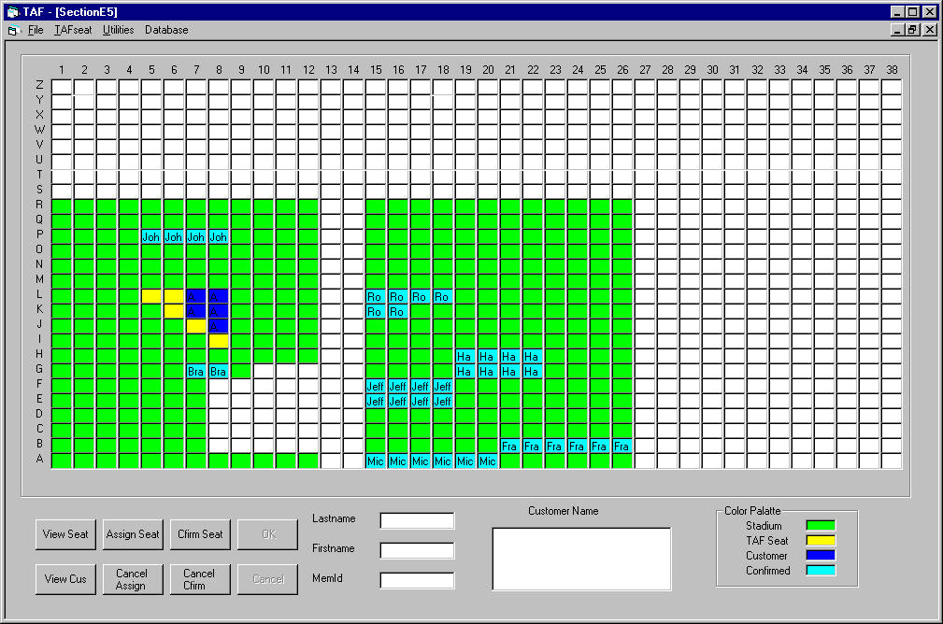
To cancel an assigned seat click [Cancel Assign] and click the seat on the map you want to cancel -- click [OK], and the seat's assignment will be cancelled. The Database will keep record of the change. The category will be changed back to “TAF”. For example, if you want to cancel the seats 'L5' and 'L6' of Customer Abdalla A. Buddy, the result should look like the following: (Fig 16)

Fig 16

- Confirm customer seat:
Follow the path [Cfirm Seat]->Click the customer seats you want to confirm. For example if you want to confirm the seats assigned to Abdalla A. Buddy, choose them from the map and click [OK], a form will pop up askng for the customer’s donation, priority and Club level. The results will look like the following: (Fig 17)
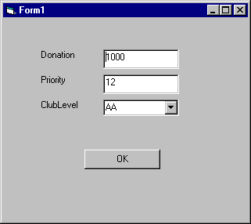

Fig 17 Fig 18

The dafault donation is 0. For example, if the customer’s donation is $1000, priority 12, Club level is ‘AA’. Fill it in like Fig 18 and click [OK]. The Database will keep record of the change. The seat category will now be “Cfirmed”.
Remark: In the second phase of implementation, Fig17 should contain the default club level should be the previous club level of that customer.

- Cancel the seat confirmed by customer:
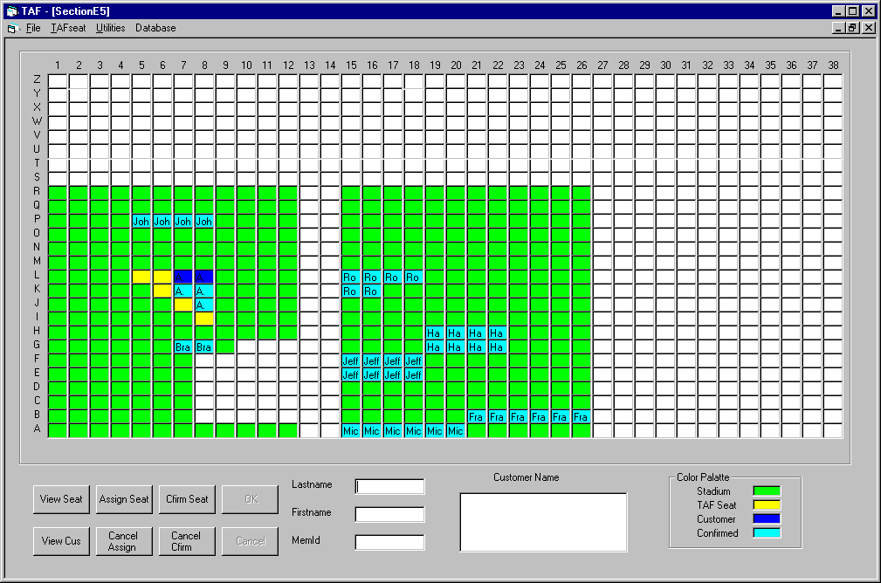
Follow the path [Cancel Cfirm] and click the seat on the map you want to cancel, then click [OK] and then the confirmed seats will be cancelled as seats not confirmed. For example, you want to cancel 2 seats in row L confirmed by customer Abdalla A. Buddy; the result will look like the following: (Fig 19)

Fig 19

The Database will keep record of the change. The category will be “Customer”.
[Cancel] Button is used to cancel an operation before you click the [OK] button.

- Create an report about Customer/Section/Club Level:
- Create a report about the Customer:
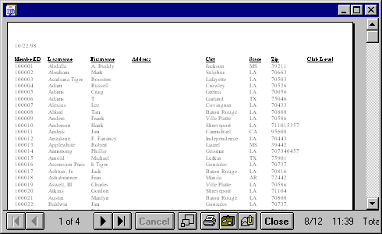
Follow the menu path [Utilities]->[Report Utilities]->[Customer Info Report], the result will be the following. This report can be viewed and printed. (Fig 20)

Fig 20

- Create a report about the Section:
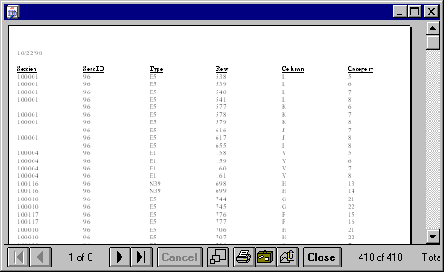
Follow the menu path [Utilities]->[Report Utilities]->[Section Info Report], the result is as the following and the report can be viewed or printed. (Fig 21)

Fig 21

- Create a report about the Club Level:
Follow the menu path [Utilities]->[Report Utilities]->[Club Info Report], the result is as the following, and the report can be viewed or printed. (Fig 22)

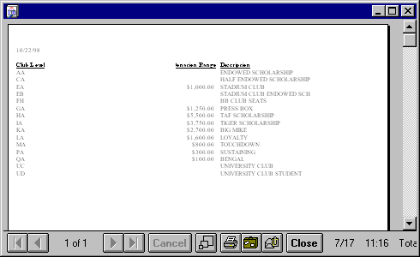
Fig 22

- Display information about Customer/Section/Club Level:

- Display detailed information about the customers:
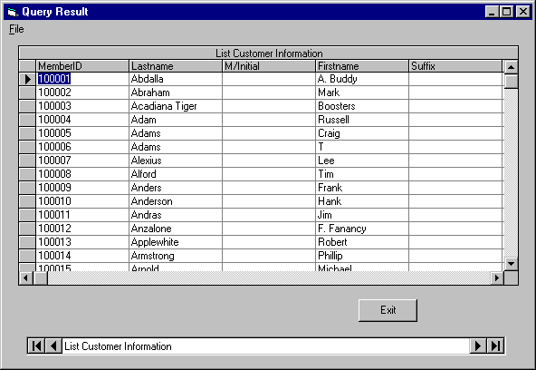
Follow the menu path [Utilities]->[Display Utilities]->[Display customer information], the result is as follows: (Fig 23)

Fig 23

- Display detailed information about the section:
Follow the menu path [Utilities]->[Display Utilities]->[Display Stadium Section information], the result is as follows: (Fig 24)

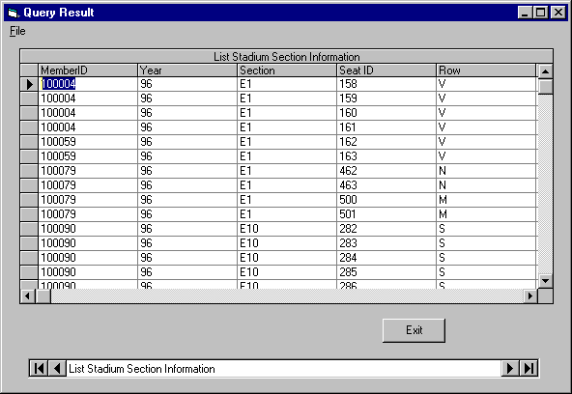
Fig 24

- Display information about the club level:
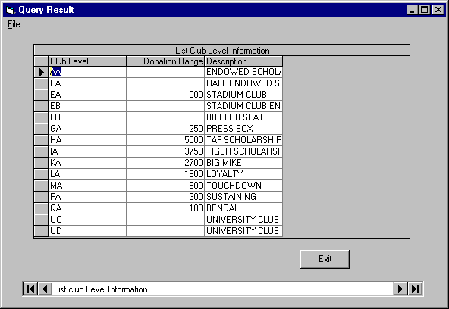
Follow the menu path [Utilities]->[Display Utilities]->[Display Club Level information], the result is as follows: (Fig 25)

Fig 25

- Doing Query operation:
The program also allows you to create a wide array of queries. Follow the menu path [Utilities]->[Query Utilities]->[Query Builder], the 'Query Builder' form will appear as the following: (Fig 26)

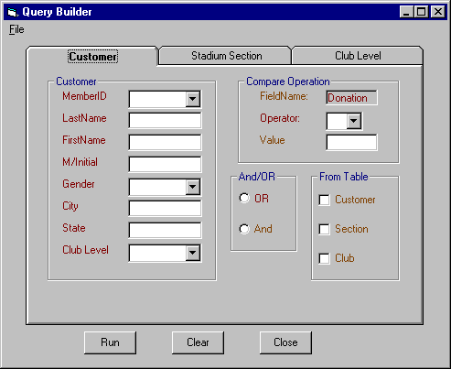
Fig 26

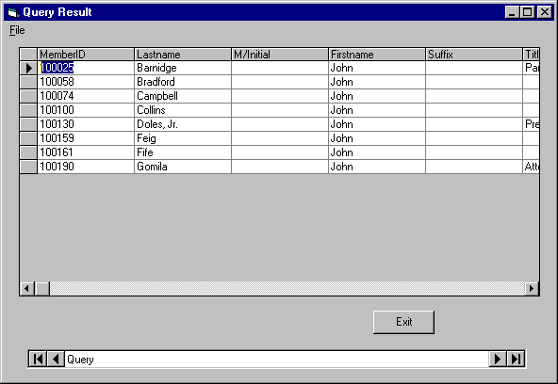
You can run a query according to your own specific criteria. For example, if you would like to see all of the customer with their first name john in the customer, select the 'customer' tab, then type john in the ‘firstname’ textbox, then click [Run], The result will appear as the follows: (Fig 27)

Fig 27

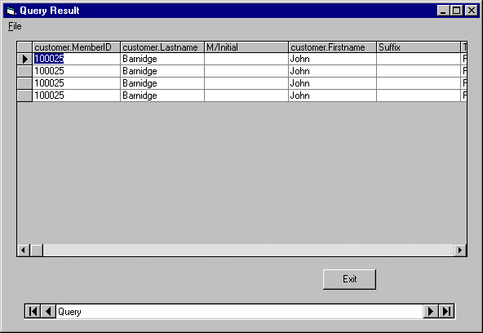
You can also run multiple criteria queries. For example, if you want to see how many seats are assigned to a customer with his firstname john in section "E5", you just type E5 in the section text box under the section tab, and type john in the 'firstname' textbox. Then click [Run] to run the query to create the following result. (Fig 28)

Fig 28

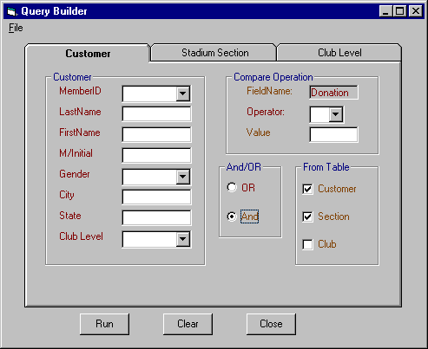
You also have the option to specify the query logic relation when you run the query. You can choose to use the <and> relation or the<or> relation. You can also specify the specific tables you want to run the query. Multiple tables can be specified at the same time. The default relation of query is <and>. The following is an example of a query with an <and> relation from the table 'section' and ‘customer’. (Fig 29)

Fig 29

- Query operations for a person who is skilled in Standard Query Language:

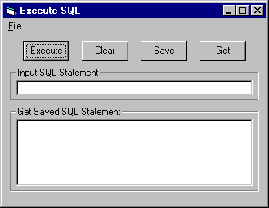
The query builder discussed above is for users who do not know SQL; we have also provides another query tool for those users who do know SQL. Follow the menu path:[Utilities]->[Query Utilities]->[Execute SQL Search], the "Execute SQL" form will appear as the follows: (Fig 30)

Fig 30

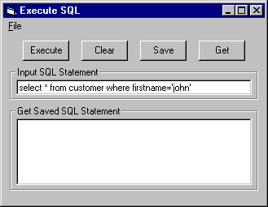
You can enter an SQL Statement into the "Input SQL Statement" textbox and click the [Execute] button to run the query. For example, if you entered the following SQL statement into the textbox: (Fig 31)

Fig 31

Click the [Execute] Button to run the query, the result is as follows: (Fig 32)

Click the [Execute] Button to run the query, the result is as follows: (Fig 32)

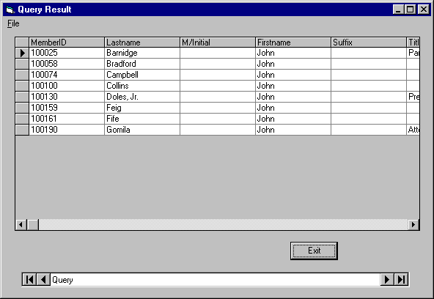
Fig 32

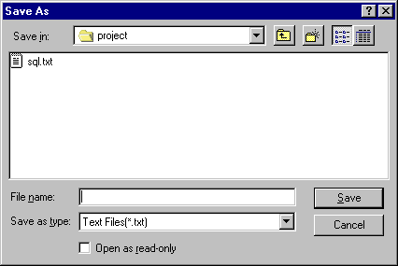
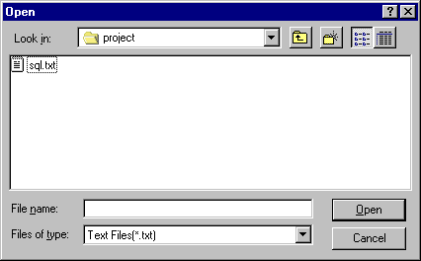
You can also save query statements that you use often into a file and execute them whenever needed. Once you enter an SQL statement into the text box, click the [Save] button and assign the query a name. (Fig 33)

Fig 33 Fig 34

When you want to pull up a saved query, just follow the path [Get] and select the file you have saved and open it. (Fig 34). The saved SQL query will appear on the "Get Saved SQL Statement" Listbox. You can then select the requested query from the list box and then click [Execute] to run the query. The [Clear] button is used to clear all of the contents of the textbox and listbox.

- Database Operation:
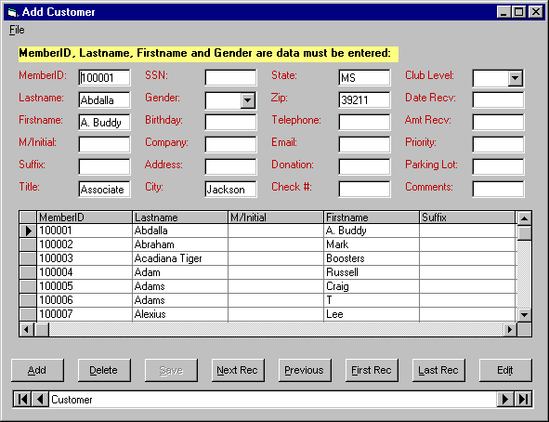
Follow the menu path: [Database]->[Add/Delete/View], to access the database operations. The "Add Customer" form will appear and will allow you to add/edit or delete items from the database. (Fig 35)

Fig 35

You can add a new customer, delete an old customer, edit customer data, and view different customer data using the navigating button on the data controls and the dB grid.
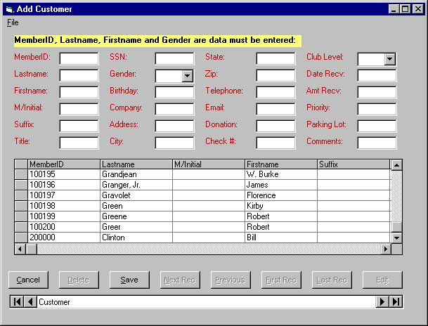
When you add new customer, you need to clear the all of the text boxes, this can be done by clicking the [Add] button. All of the text buttons will be cleared and the new item can be entered. (Fig 36)

Fig 36

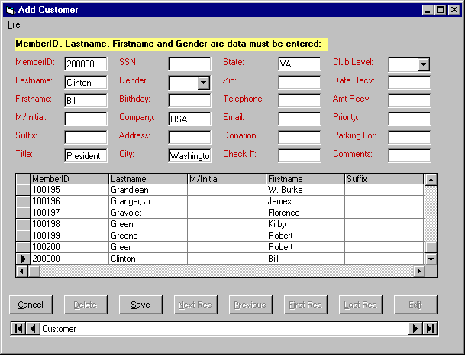
To add the new item simply enter in the necessary information and click [Save] to update the database. Before you click [Save], if you decide not to create the entry you can also click [Cancel] to cancel the operation. If you want to change a customer's data, just navigate to his record and click [Edit]. For example, if you want to change a field for the record of customer Clinton, simply navigate to his record and click [Edit], the following appears: (Fig 37)

Fig 37

You can now make the necessary changes to the data of customer Clinton. After you finish entering the changes, click [Save] and the database will be updated. If you change your mind, just click the [Cancel] and the database will not be updated.

We also provide a form in Microsoft Access that allows you to add/edit/delete database items. So you can choose to change the customer data in either application.

There are also some validation requirements that are included in the design of table. For example, the lastname must all be alphabetic and the MemberID must consist of digits. Also the SSN must follow the format: ###-##-####, etc.

- Things to Consider

1. Tradeoff between speed and space
For this Visual Basic project, we have developed two versions of our application. The first incarnation runs a much slower than the second takes up much less disk space. The second version is runs much faster but takes up much more space. The reason is in the first version, we used one form for all of the sections and the section maps are loaded when the program is running. The stadium seats are all stored in the access database. By searching the database, we load the section map and search for the seats. Since all section seats are stored in the database, it is very slow when you run a query.

The second version is running much faster due to the fact that we have created a different form for each section and section maps are drawn at design time. So the map does not need to be loaded while the application is running and we do not need search the database each time. We also only have to store the TAF seats into the database so the query functions run very fast. However, the trade-off is that it takes up much more drive space. We have opted to use the second version, which allows more convenience and efficiency to the end user.

2. Year-end Transition
Since we are very concerned with the speed of our application, we are only storing the customer data for the current year. At the end of the year, the user has to store the last year's data and reset the database. If the user wants to search the other year's data, the user has to copy the data back to the data file currently in use and carry on the query.

3. The Parking
We have chosen to associate parking with the customer, not with their tickets. Our reasoning is that one customer may order 6 tickets but only order 2 parking passes. So we added a field in the customer table for parking. If a customer orders a parking pass, just add the parking lot position into the field associated with the customer.

- Suggestions for future development

Although our entire team has spent a great deal of time and effort on the development of this application, due to the time constraints this program is not perfect. There are always improvements that can be made to any application.

The first suggestion would be to add more function on the searching and query. A statistics function could be added that would enable the user to calculate statistical data about the customer. Queries could be created to show the total donation of the customer, the total donation of a particular year, or the number of tickets the customer has ordered. It might also be useful to show the comparison of different year's selling, etc.

Our second suggestion would be to eventually move the interface online. We can use a Client-Server structure for this. We could put the interface on the web, client side, and put the access database and the CGI background on the web server side. The user could then operate the system form different computers provided they are authorized to access with a password. This could also allow TAF members to view online what seats they have to choose from.

Another improvement deals with the parking. We have only provided a field for user to specify a parking space for the customer. We could possibly make the parking function stronger so that the user can search for available parking spaces or do more complex operations. Another enhancement could be to make the interface in 3-Dimensional. This possible improvement as well as the others would help to make the application more appealing.

The time constraints imposed by completing this project during summer school have left some room for improvement. However, we are very confident and are very satisfied with what we have done in this short time of development. Our group has had a very pleasant experience working together and overall we feel that this has been a very challenging project as well as educational. If the future developers have any questions, please feel free to contact us through the contact information that is listed below.

- Developer's information

- Yifeng Zhang: Department of Computer Science Email: zhyf@bit.csc.lsu.edu
- Huidong Ma: MBA Email: hma1@tiger.lsuiss.ocs.lsu.edu
- Michael Loft: ISDS Email: mloft@earthlink.net
- Xiaojun Ding: Department of Architecture Email: xding1@tiger.lsuiss.ocs.lsu.edu

