Class Evaluation Survey Program

Huidong Ma

- General Description.

Every Semester, students fill out the evaluation surveys for each class. After the surveys are collected, the data analysis is a tedious and time consuming process even with the help of some electronic reading device. So the instructors can hardly make full use of the surveys to improve their teaching.

In order to solve this problem, I write the Class Evaluation Survey Program for MIS department in ABAP/4. This program has two advantages. First, it is widely accessible to the instructors and students, because all the MIS students have access to the SAP system. Second, it produces the analysis reports instantly.

This program has two parts. One is Survey part, the second is Report part.

This Survey contain 4 parts. First part is Survey Registration, students fill out the Year, Semester, Department, Course number, Section Number and survey ID which make the primary key of the table. Second part is student self-rating, contains information about self-rating about student’s study effort in this course. Third part is to rate instructor’s teaching. Final part is to provide student information and the suggestion and comments about the class.

The Report is to show the cumulative number of every choice and list all the comments and suggestions.

From this semester on, the students and instructors in MIS department will use this program to make the class evaluation survey.

Components of Survey.

1). Components of the Survey part (Fig.1)

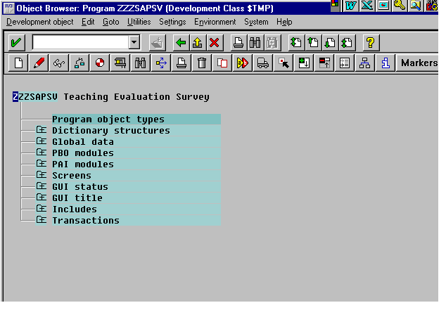
Fig. 1

2). Major table contains survey information (Fig.2)

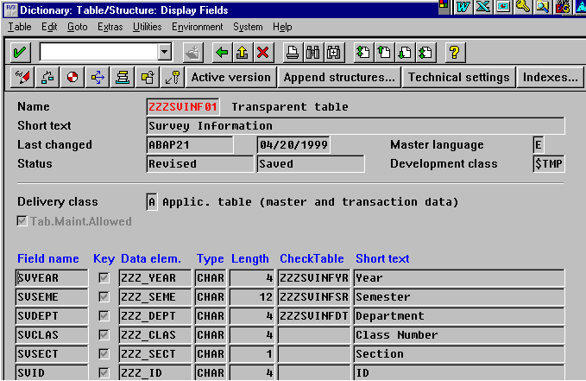
Fig. 2

3). Data Model for all related tables. (Fig.3)

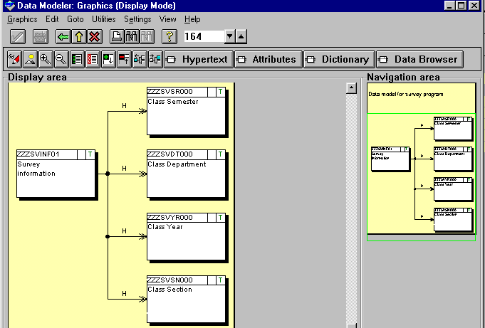

4). Sample code of PAI module (Fig.4)

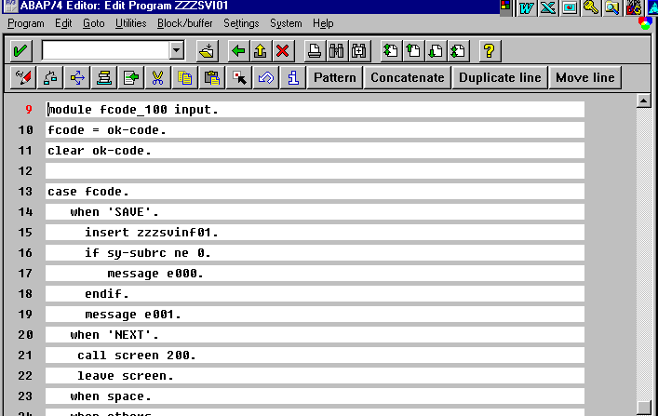
Fig.4

5). First Screen of the Survey (Fig. 5)

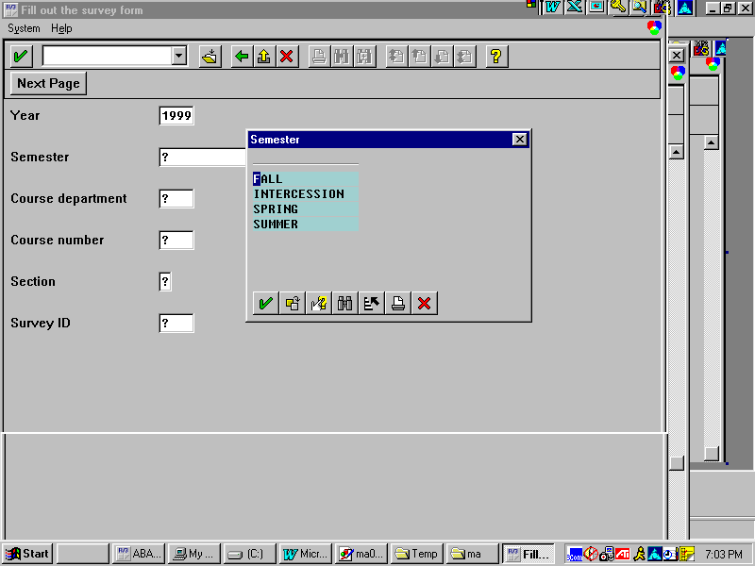

Fig.5

6). 2ND screen of the program (Fig.6)

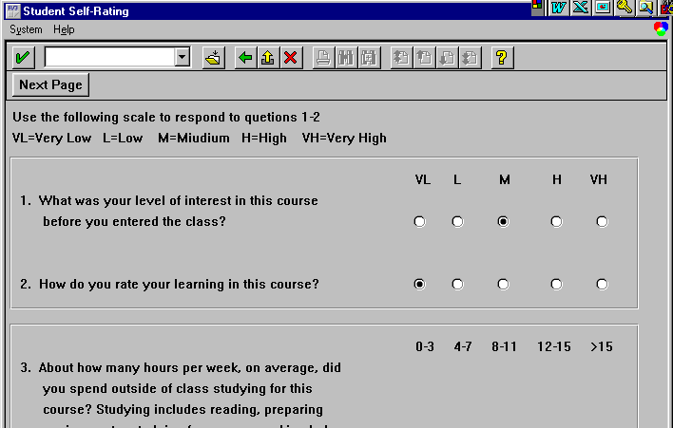

Fig.6

7). 3RD screen of the project (Fig.7)

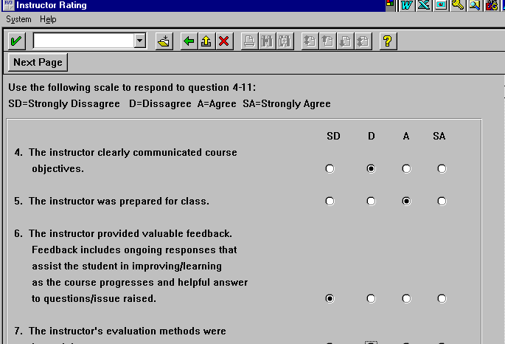

8). 4th screen of the program. (Fig.8)
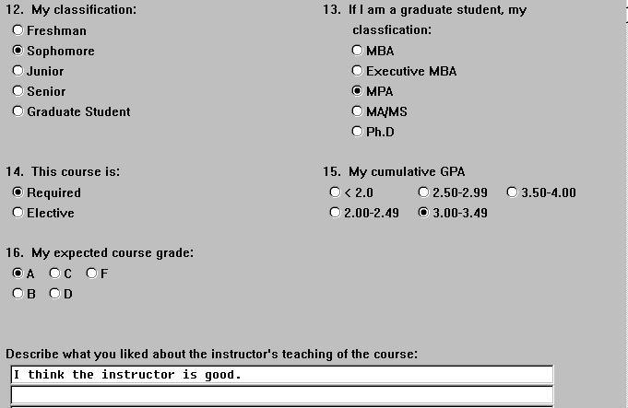
Fig.8

Following are the components of Report part.

9). Sample code of the report. (Fig.9)
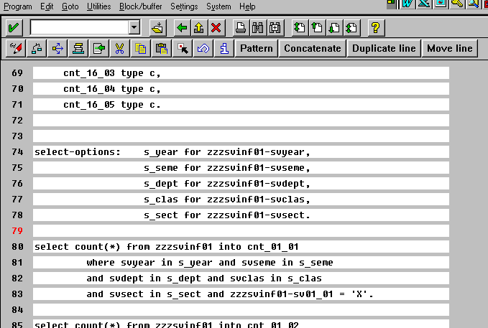
Fig.9

10. Selection screen for the Report.

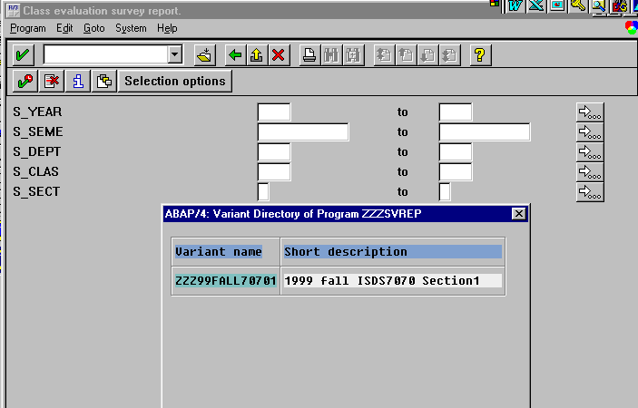
Fig.10

11. Report Result (Fig.11)
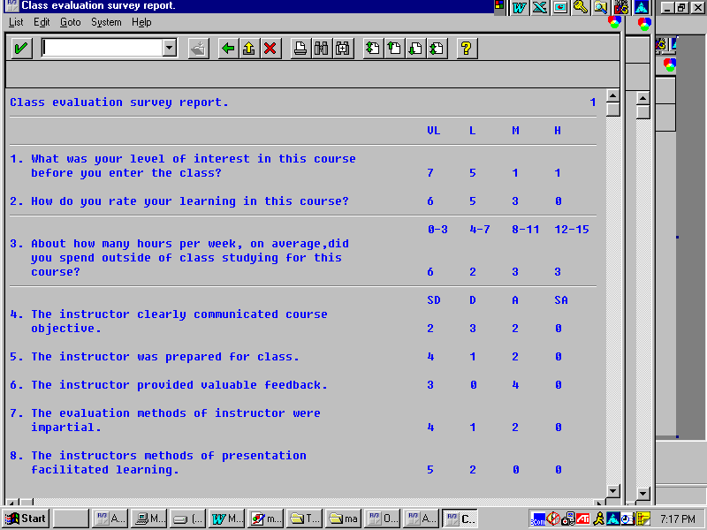
Fig 11.

